PHASE 1 — Freeze the academic truth
Before deciding what to teach, establish a hierarchy of authority.
Source hierarchy
- Latest formal EMSLearn announcements
  - assessment scope;
  - format;
  - changed dates/instructions.
- 2026 SDS188 Module Framework
- 2026 lecturer slides
- official tutorials
- official tutorial memoranda
- lecturer recordings/transcripts
- prescribed textbook / lecturer-supplied textbook extracts
- existing HTML manuals and formula sheets
- AI-generated explanations/practice questions
Anything from levels 8–9 is secondary, even if it looks excellent.
This matters because the existing Chapter 7 HTML is useful, but we should never allow an old/generated HTML to silently override the current lecturer material.
The framework itself specifically tells students to attempt tutorial problems independently before seeing the answers. More importantly, the Chapter 6 lecture transcript says the tutorials should be attempted as if in the assessment, without notes, because otherwise students can develop false confidence; the lecturer also notes that tutorial-style questions can closely resemble assessment questions.
That should become a core design principle of our system.

PHASE 2 — Ask the Brain Project before designing the final architecture
We don't want the Brain Project auditing statistics content.
We want it answering:
How should this material be taught so that Nix can actually retrieve and apply it under closed-book assessment conditions?
It should challenge our learning design before we inspect the existing HTMLs, so we're not biased by what has already been built.
Prompt to give the Brain Project
SDS188 A1S2 MASTER LEARNING SYSTEM — LEARNING-DESIGN ADVISORY ONLY
I am designing a personal interactive HTML learning system for Statistics and Data Science 188 at Stellenbosch University.
Do not build the HTML and do not invent statistical content.
I want a learning-design advisory that will later be combined with an audit of my official academic sources.
ASSESSMENT
A1S2:
- 29 August 2026
- scope: Chapters 6–9
- EMSLearn quiz
- invigilated
- closed book
- approximately 90-minute assessment window based on the announced sessions
The official module framework describes A1S2 as the semester's computer-based assessment and the later A2S2 as a written assessment.
I currently have substantial material for Chapters 6–8.
I do NOT yet have Chapter 9 material.
Do not guess what Chapter 9 contains.
PRIMARY PERFORMANCE GOAL
Design the learning architecture around achieving approximately 70–100%, particularly by preventing:
- passive familiarity being mistaken for mastery;
- formula-selection errors;
- wrong-tail/wrong-distribution errors;
- notation confusion;
- calculator/Excel procedure errors;
- inability to recognise a question when its wording changes;
- correct calculations with incorrect interpretation;
- dependence on notes;
- poor time management in an invigilated quiz.
The HTML must teach first, then progressively remove support until the student can solve unseen mixed problems independently.
I WANT YOUR ADVICE ON
- The ideal learning progression for quantitative/statistics material.
- What evidence should count as actual mastery.
- How diagnostic testing should work.
- How retrieval practice should be implemented.
- How worked examples should fade from fully guided → partially guided → independent.
- How an error/repair system should operate.
- How formulas should be learned and selected rather than merely displayed.
- How graphs/visual probability regions should be taught.
- How calculator and Excel procedures should be trained without creating procedural dependence.
- How conceptual questions and calculations should be interleaved.
- How to train for multiple-choice/numeric-entry traps and altered wording.
- How timed closed-book simulations should work.
- How spaced revision should be scheduled between now and 29 August.
- How the system should decide “WHAT SHOULD I DO NOW?”
- Which features would add cognitive load or amount to overengineering and should therefore NOT be built.
IMPORTANT DESIGN REQUIREMENTS
The system should distinguish:
- seeing an answer;
- understanding an answer;
- recalling the method;
- solving a familiar problem;
- solving a changed/unseen problem;
- solving under time pressure.
A revealed solution must never count as mastery.
Self-declared confidence must not be enough to unlock mastery.
Mistakes should automatically generate later repair/retest work.
The system should favour active production over passive rereading.
It should include short opportunities to explain reasoning aloud before revealing answers where useful.
The final goal is that the learner can close the HTML and perform.
OUTPUT
Give me:
- MUST HAVE learning-design features.
- SHOULD HAVE features.
- DO NOT BUILD / LOW VALUE features.
- Recommended mastery-state architecture.
- Recommended structure for a single chapter.
- Recommended structure for mixed assessment preparation.
- Recommended 20-day progression toward A1S2.
- Any weaknesses you see in this proposed approach.
Be critical rather than agreeable.
Prioritise learning effectiveness over visual novelty.
Do not make claims about the SDS188 syllabus that were not supplied above.
That is the next step.
SDS188 A1S2 Master Learning System — Learning-Design Advisory
Executive verdict
The core idea is strong, but I would make two non-negotiable changes before this becomes a build specification:
- Do not make the HTML more elaborate than the learning problem. For SDS188, the system should behave primarily as a question-recognition → method-selection → execution → interpretation → repair engine, not as a digital textbook, analytics dashboard, or gamified study app.
- Do not compensate for missing Chapter 9 with assumptions. Chapter 9 should exist in the architecture as SOURCE MISSING / NOT YET AUDITED, with no inferred topics, prerequisites, formulas, or questions until the official material is obtained.
The most important design principle should be:
The HTML teaches with support, measures with reduced support, and finishes by removing itself.
A student who performs beautifully inside the HTML but cannot solve a fresh closed-book problem after closing it has not achieved the objective.
This fits the existing Brain project boundaries particularly well: missing evidence remains unknown; a revealed answer cannot establish competence; one successful repair attempt does not close a bottleneck; and task-local performance should drive the next action rather than passive completion.
For your particular implementation, I would also externalise multi-step decision processes rather heavily during learning. Your assessment report shows a relative weakness in immediate auditory short-term memory/Digit Span alongside much stronger arithmetic performance, which makes persistent decision strips, written notation, and visible intermediate structure reasonable supports—not because of a supposed “learning style”, but because they reduce unnecessary working-memory load while leaving the mathematical reasoning to you.

1. MUST HAVE
A. One universal SDS problem-solving spine
Almost every quantitative activity should eventually be forced through the same content-neutral reasoning chain:
RECOGNISE → REPRESENT → SELECT → EXECUTE → INTERPRET → VERIFY
During learning, the HTML explicitly prompts each step.
1. RECOGNISE
Ask:
- What is this question actually asking for?
- What information matters?
- What wording is signalling the required statistical operation?
- What information is distracting or irrelevant?
2. REPRESENT
Require whatever representation the audited source supports:
- notation;
- probability statement;
- graph/region;
- parameters;
- known versus unknown quantities.
3. SELECT
Before calculation:
- which method?
- which formula?
- which distribution, where relevant?
- which tail/region, where relevant?
- why does it apply?
4. EXECUTE
Only now:
- calculator;
- Excel;
- arithmetic;
- substitution.
5. INTERPRET
Require the answer in the language/context of the question, not just a number.
6. VERIFY
Ask:
- Does the magnitude make sense?
- Is the sign/direction plausible?
- Is the selected region consistent with the wording?
- Did I answer the requested quantity rather than a related one?
By late-stage practice, those prompts disappear entirely.

B. Evidence hierarchy: not all “success” is equal
The HTML must record these as fundamentally different things:
Evidence | What it proves
Saw solution | Nothing about independent competence
Followed solution | Can follow reasoning with support
Explained solution afterwards | Provisional understanding
Recalled method closed-source | Retrieval evidence
Solved familiar independent problem | Application evidence
Solved altered/unlabelled problem | Transfer/discrimination evidence
Solved mixed altered problem after delay | Strong stability evidence
Solved mixed altered problem under representative time | Assessment-performance evidence
Hard rule
If solutionViewed = true before submission:
That attempt can teach, but cannot upgrade mastery.
The same applies to substantial hints.
This should be enforced technically rather than left to self-discipline.

C. Diagnostic system
Do not begin every chapter by reteaching everything.
Each source-ready chapter should start with a small representative diagnostic, sampling distinct operations rather than simply counting questions.
The diagnostic should test, where relevant to the audited material:
- concept recognition;
- notation;
- formula/method selection;
- distribution/tail recognition;
- visual probability region;
- calculation;
- calculator/Excel execution;
- interpretation.
Diagnostic rules
The diagnostic should initially hide:
- chapter subsection;
- method name;
- formula;
- hints.
For every item, record:
- correctness;
- selected method;
- confidence;
- support used;
- final interpretation;
- time if useful.
Then classify the result narrowly.
For example:
Wrong final answer + no working recorded
→ ERROR TYPE UNKNOWN
Not:
→ “formula problem.”
The program must never pretend to diagnose the cause of an error from insufficient evidence. That unknown-safety rule is one of the strongest principles in the existing Brain architecture.

D. Worked-example fading
This should be one of the main teaching engines.
Level 1 — Fully modelled
Show:
- question analysis;
- representation;
- method selection;
- formula;
- substitution;
- tool procedure;
- interpretation;
- checking.
But require the learner to answer short “why this step?” prompts.
Level 2 — Completion example
Remove selected parts.
The learner completes:
- missing notation;
- missing region;
- formula choice;
- one calculation step;
- interpretation.
Level 3 — Structural prompts only
Show:
Identify → Represent → Select → Calculate → Interpret
No actual solution steps.
Level 4 — Familiar independent
Same underlying operation, but no scaffold.
Level 5 — Altered/unlabelled
Change the surface structure:
- different wording;
- different context;
- information reordered;
- method label removed;
- graph ↔ words where academically valid.
Level 6 — Mixed independent
The learner does not know what chapter/subsection produced the question.
Level 7 — Timed mixed
Representative assessment conditions.
Crucial rule
One successful Level 4 problem means:
reduce support and test again.
It does not mean mastery.

E. A genuine repair engine
Every meaningful wrong answer must create future work.
Recommended error families:
Error family | Examples
Recognition | Misread what the question wanted
Selection | Wrong method/formula chosen
Distribution | Wrong distribution selected
Tail/region | Wrong probability region
Notation | Symbols/parameters confused
Formula knowledge | Formula incorrectly recalled
Substitution | Correct formula, wrong values inserted
Procedure | Calculator/Excel sequence incorrect
Arithmetic | Mechanical calculation error
Interpretation | Number correct, conclusion wrong
Graph | Region/axis/quantity represented incorrectly
Rounding/input | Numeric-entry or formatting error
Timing | Correct method but excessive time
Confidence mismatch | Very confident + materially wrong
Repair sequence
A repair should normally be:
ERROR → EXPLAIN → CONTRAST → RETRY → DELAY → TRANSFER
For example, a formula-selection error should not trigger ten identical calculations.
It should trigger:
- identify the cue that was missed;
- compare two superficially similar cases;
- choose between them and explain why;
- solve one;
- return later;
- solve an altered version.
For a procedural keying error, the repair can be much shorter.

F. Formula-selection training
A formula sheet by itself is low-value.
Each formula should eventually be stored internally as a decision object, not just an equation.
For every audited formula, the learning system should teach:
FORMULA
→ What question does this answer?
→ What information must exist?
→ What conditions make it appropriate?
→ What similar formula is it easily confused with?
→ What wording should make me consider it?
→ What would rule it out?
Then train the reverse direction.
Do not repeatedly ask:
“State formula X.”
Also ask:
“Here is a question. Which formula family do you need, and why?”
Then later:
“Here are three methods. Why are two wrong?”
That is much closer to the actual danger you identified: selection failure rather than simple formula amnesia.

G. Graph / visual-region training
Do not make graph activities purely decorative.
For probability-region questions, use the progression:
WORDS → EVENT → REGION → TAIL(S) → METHOD → CALCULATION → INTERPRETATION
Where supported by the audited material, activities can include:
- read wording and shade the region;
- see a region and describe it in words;
- write the symbolic event;
- identify which method corresponds to it;
- detect a deliberately wrong shaded region;
- solve without the visual scaffold.
Important
Require the region decision before calculation.
Otherwise the learner can type something into a calculator, obtain a number and never discover that the conceptual region was wrong.

H. Calculator and Excel training without dependency
Use two separate layers:
Layer 1 — statistical reasoning
The learner must first determine:
- what is being calculated;
- what method applies;
- what inputs mean;
- what result should represent.
Layer 2 — tool execution
Only then show calculator/Excel implementation.
Progress through:
VIEW → COMPLETE → RECONSTRUCT → EXECUTE FROM QUESTION
Eventually:
No tool instructions.
The student receives only the problem.
Critical boundary
A correct calculator or Excel output should not establish mastery if the program supplied the correct statistical method automatically.
Likewise, manual calculation should not be forced merely for purity if the official assessment expects a permitted tool. The eventual source audit must determine what tool behaviour A1S2 actually requires.
I would therefore avoid coding assessment-specific Excel/calculator assumptions until that audit.

I. Interpretation gate
A calculation is not finished when the number appears.
Require:
What does this answer mean here?
The system should separately store:
- calculationCorrect
- interpretationCorrect
Therefore:
correct number + wrong interpretation
≠ fully correct problem.
This is particularly important for your 70–100% target because calculation competence can conceal conceptual weakness surprisingly well.

J. Altered-wording training
This is absolutely essential.
Build validated question variations, not merely repeats.
Safe variation dimensions include:
- changing context;
- changing variable names;
- reordering information;
- removing the subsection heading;
- changing whether information is given verbally or symbolically;
- inserting irrelevant information;
- asking for interpretation rather than calculation;
- graph → words;
- words → graph;
- asking the method-selection step explicitly;
- changing numerical values while preserving the validated structure.
Do not automatically generate statistics questions with AI
Unless those variants are checked against official material.
A beautifully adaptive system containing subtly invalid statistics questions would be worse than a small verified question bank.

K. Closed-book mode
There should be a prominent:
CLOSE THE NOTES
mode.
It must disable:
- formula reference;
- worked examples;
- chapter labels;
- hints;
- glossary;
- method names;
- explanation panes.
The learner should repeatedly encounter:
Can I do this if the HTML disappears?
That is the actual target.

2. SHOULD HAVE
These are valuable after the core engine works.
Confidence calibration
Before substantive questions:
- Guessing
- Unsure
- Fairly sure
- Very sure
Pair it with actual performance.
Repeated:
Very sure + wrong
should trigger a misconception/discrimination check, not a motivational message.
Repeated:
Unsure + independently correct
should trigger another independent problem rather than unnecessary reteaching.

Question-trap laboratory
Especially useful for an EMSLearn assessment.
Include verified examples of:
- tempting wrong formula;
- wrong-tail distractor;
- wrong-distribution distractor;
- correct calculation answering the wrong quantity;
- plausible rounding option;
- answer produced by a common procedural error.
After submission, ask:
What mistake would produce each distractor?
That transforms MCQ distractors into learning material.

Numeric-entry discipline
Train:
- calculate at adequate precision;
- interpret;
- apply the required rounding/format only once the official requirements are known;
- enter exactly what is requested.
Do not invent EMSLearn formatting rules before the source audit.

Scratch workspace
A persistent scratch area should allow:
- notation;
- small diagrams;
- intermediate calculations;
- reasoning notes.
This reduces unnecessary working-memory demands without doing the reasoning on the learner's behalf. Given the cognitive profile in the supplied report, that is a sensible implementation choice.

“Say it before reveal”
Use selectively:
Before revealing the answer, explain aloud why you chose this method.
Keep it to perhaps 20–60 seconds.
Do not require recordings or automatic speech analysis.
The later independent question establishes correctness.

Error fingerprint
The system can show a simple factual summary such as:
Recent errors:
3 selection
2 interpretation
1 procedure
This can help route practice.
Do not turn it into:
“You are a distribution-selection learner.”

Source and content status
Every chapter should have an internal status:
- SOURCE READY
- SOURCE PARTIAL
- SOURCE MISSING
- AUDIT REQUIRED
At present:
Chapter 9 = SOURCE MISSING.
That is a content-control fact, not a mastery state.

3. DO NOT BUILD / LOW VALUE
This is where I would be strict.
Do not build:
- a global “87% mastered” score;
- XP, streaks, coins or achievement badges;
- confetti;
- a giant analytics dashboard;
- a complicated AI tutor inside the HTML;
- automatic AI-generated statistics questions;
- a huge searchable formula encyclopedia;
- a full Excel clone;
- a full calculator emulator unless later evidence shows it materially improves practice;
- dozens of mastery sublevels;
- microphone scoring;
- automatic psychological profiling from mistakes;
- forced study timers on every activity;
- fixed 25-minute Pomodoro mechanics;
- dozens of charts tracking study behaviour;
- elaborate animations;
- “completed” status from page scrolling;
- progress from clicking Show solution;
- permanent prerequisite locks;
- a separate game for every chapter;
- a second full set of notes inside Learn Mode duplicating Read Mode.
Especially do not build a “smart error diagnosis” that guesses from the final answer.
If a learner submits 0.0314, there may be many reasons it is wrong.
Without working or a diagnostic follow-up:
cause = unknown
That is scientifically and educationally much safer.

4. Recommended mastery-state architecture
I would not create a seven- or eight-stage SDS-only mastery vocabulary.
Keep the existing Brain vocabulary for consistency:
NOT STARTED → UNDERSTAND → RETRIEVE → APPLY → STABLE
with:
REPAIR as an override.
Then keep assessment evidence separate.
State definitions
NOT STARTED
No valid learning evidence.
UNDERSTAND
Can explain the concept/method correctly and pass an immediate conceptual check without reading the answer.
RETRIEVE
Can reconstruct the relevant idea/method/formula from memory.
APPLY
Can independently solve a representative familiar problem.
STABLE
Performance survives:
- delay;
- reduced support;
- changed wording/unseen representation;
- mixed selection.
REPAIR
Recent representative evidence reveals a meaningful error that requires retesting.

Separate evidence flags
Attach flags such as:
- solutionViewed
- independent
- familiar
- changedWording
- mixed
- delayed
- timed
- interpretationCorrect
- selectionCorrect
- toolProcedureCorrect
This gives you the distinctions you want without multiplying mastery states.

Assessment readiness is not another mastery state
Create a separate gate:
A1S2 READY
Require something like:
- all required chapters source-ready;
- no major open repair affecting assessed work;
- appropriate concepts at least APPLY/STABLE;
- altered/unseen performance demonstrated;
- mixed selection demonstrated;
- interpretation demonstrated;
- closed-book evidence;
- representative timed evidence.
The exact academic coverage cannot be finalised until Chapter 9 and the official sources are audited.

5. Recommended structure for a single chapter
Each chapter should feel like a training course, not a long scrolling document.
1. Chapter Gate
Show:
- source status;
- what the learner will need to demonstrate once source-audited;
- prerequisite warnings;
- current next task.
For Chapter 9 today:
SOURCE MISSING — academic content intentionally unavailable.

2. Diagnostic
A compact representative sample.
Output:
- what can tentatively be skipped;
- what needs teaching;
- what needs verification;
- what enters repair.

3. Learn blocks
Each concept uses:
EXPLAIN → SAY → CHECK → EXAMPLE → FADE
No passive 30-minute reading sections.

4. Recognition and selection lab
Question stems only.
Require:
- method;
- reason;
- formula/distribution/tail where relevant.
No calculations initially.
This may be the highest-value part of the system given the failure modes you identified.

5. Graph / representation lab
Words ↔ notation ↔ visual region.

6. Calculation lab
Independent numerical execution.

7. Tool lab
Calculator/Excel implementation after reasoning.

8. Interpretation lab
Give results and ask what they mean.
Sometimes no calculation at all.

9. Worked-example fading ladder
Full → partial → prompted → independent → altered → mixed.

10. Chapter mixed set
Do not label subsection or method.

11. Chapter Final Boss
Closed-source, altered wording, mixed tasks.
No hints.

12. Repair queue
Only actual unresolved errors.

13. Chapter exit
Possible states:
Needs teaching
Building
Independent on familiar tasks
Stable on changed/mixed tasks
Repair required
No percentage required.

6. Mixed A1S2 assessment preparation
Chapter-by-chapter competence is not enough.
The assessment-preparation layer should progressively destroy contextual clues.
Stage A — labelled mixed practice
Questions from several chapters, but chapter/topic labels remain.
Purpose: integrate calculation.
Stage B — unlabelled mixed practice
No chapter names.
Purpose: selection.
Stage C — altered wording
Same validated academic operation, different surface form.
Purpose: transfer.
Stage D — trap sets
MCQ/numeric-entry distractors based on known error patterns.
Purpose: discrimination.
Stage E — mini closed-book blocks
Short, mixed independent blocks.
Purpose: concentration and switching.
Stage F — full simulation
Representative EMSLearn-style conditions as far as verified.
Currently known:
- closed book;
- invigilated;
- computer based;
- Chapters 6–9;
- approximately 90-minute announced session window.
Do not invent anything beyond that.
If your actual approved assessment time differs because of formal concessions, the simulator should eventually use the official confirmed personal time, not an assumed value.

Simulation review
After every simulation, divide errors into:
Knowledge gap
Didn't know the concept/method.
Selection gap
Knew it but chose the wrong thing.
Execution gap
Correct method; procedural/arithmetic error.
Interpretation gap
Correct work; wrong meaning/conclusion.
Time-pressure gap
Correct untimed, deteriorated under timing.
Attention/read-error
Misread or omitted key information.
Then repair only what failed.
Do not respond to a 70% simulation by making the learner reread all four chapters.

7. Recommended 20-day progression
This assumes Day 1 = 9 August and the final preparation day is 28 August, with A1S2 on 29 August.
The exact chapter allocation must remain flexible until Chapter 9 arrives.
Day | Date | Main objective
1 | 9 Aug | Freeze learning architecture; baseline diagnostic on source-ready Ch 6–8; identify major error families
2 | 10 Aug | First targeted teaching/repair from diagnostic; begin Chapter 9 source acquisition as an urgent content dependency
3 | 11 Aug | Ch 6–8 weakest area: UNDERSTAND → RETRIEVE; formula/method-selection work
4 | 12 Aug | Independent familiar problems; interpretation gate; first delayed retrieval from Days 1–3
5 | 13 Aug | Next weak area; graph/region + recognition/selection practice where source-supported
6 | 14 Aug | Worked-example fading; calculator/Excel reconstruction; repair recurring errors
7 | 15 Aug | Closed-source mixed Ch 6–8 set; no chapter labels; analyse error fingerprint
8 | 16 Aug | Repair day: only weaknesses exposed by mixed work; delayed retests
9 | 17 Aug | Changed-wording/transfer practice across source-ready content
10 | 18 Aug | Chapter 9 should ideally be source-ready by here. Diagnostic + first teaching if obtained
11 | 19 Aug | Chapter 9 teaching/application OR, if still unavailable, strengthen Ch 6–8 while treating the missing source as a readiness blocker
12 | 20 Aug | Chapter 9 fading + earlier-chapter spaced retrieval; start four-chapter integration if possible
13 | 21 Aug | Full unlabelled Chapters 6–9 mixed set; selection emphasis
14 | 22 Aug | MCQ/numeric-entry trap lab + interpretation-only questions + targeted repair
15 | 23 Aug | First substantial closed-book mixed simulation, initially untimed or lightly timed if accuracy is not stable
16 | 24 Aug | Simulation repair; reproduce every material error without notes
17 | 25 Aug | First representative timed simulation if untimed readiness is sufficient
18 | 26 Aug | Deep repair from timed simulation; altered versions of failed items; short delayed retests
19 | 27 Aug | Final substantial representative closed-book simulation; focus on pacing and switching
20 | 28 Aug | Light mixed retrieval + formula/method discrimination + unresolved-error check; no large new build and no marathon rereading
29 August
The learning system should no longer be teaching you.
You should be able to close it.

Spacing inside those 20 days
I would keep R1 / R2 / R3, but treat dates as scheduler defaults, not scientific proof of mastery.
For example:
- R1: next available study session;
- R2: roughly 2–3 days after successful R1;
- R3: roughly 5–7 days later;
- REPAIR override: brings the item forward;
- a failed delayed check restarts repair rather than merely adding another tick.
Because the assessment is close, spacing needs to fit the remaining calendar. The evidence requirement matters more than slavishly obeying an exact interval. The existing Brain audit correctly warns against turning arbitrary spacing intervals into mastery rules.

8. WHAT SHOULD I DO NOW? router
This needs to be brutally simple.
The system should return one primary task.
Recommended deterministic priority:
Priority 1 — Source blocker
If assessed material is not source-ready:
Resolve the required source gap.
Currently Chapter 9 is such a gap.
This is a build/readiness issue, not evidence that you personally “don't know Chapter 9.”

Priority 2 — Open high-impact REPAIR
Choose the unresolved error most likely to corrupt multiple downstream problems.
Examples of generic high-impact types:
- wrong method selection;
- distribution/tail confusion;
- notation errors;
- formula choice;
- recurring tool-procedure errors.

Priority 3 — Due delayed retest
If an item needs a delayed check:
do that before more teaching.

Priority 4 — Required content not yet independently applied
Route:
UNDERSTAND → RETRIEVE → APPLY

Priority 5 — APPLY but not STABLE
Give:
- changed wording;
- reduced cues;
- unlabelled/mixed task.

Priority 6 — Stable individually but not mixed
Give a mixed discrimination set.

Priority 7 — Stable untimed but not timed
Give timed practice.

Priority 8 — Ready
Give brief maintenance retrieval and stop.

The next-task card should say only:
DO THIS NOW
Mixed method-selection set — Chapter X / Y
Why: Two recent problems used the correct calculations after the method was supplied, but independent method selection has not yet been demonstrated.
Do: Choose the method and justify it before calculating.
Stop when: Complete the set and repair any selection error.
That is much better than opening a dashboard with 27 statistics.

9. Major weaknesses / risks in the proposed approach
1. Chapter 9 is currently the biggest structural risk
No learning architecture can compensate for missing assessed material.
If Chapter 9 arrives very late, it may:
- require prerequisite restructuring;
- alter the mixed-question bank;
- change time allocation;
- expose previously unknown weak areas.
Therefore source acquisition for Chapter 9 is now time-sensitive.

2. The HTML itself could become the procrastination mechanism
This is the biggest danger I see.
You have 20 days.
A sophisticated statistics OS is valuable only if it rapidly increases actual problem attempts.
By around the first few days, I would freeze:
- navigation;
- mastery engine;
- error system;
- next-task router;
- fading model.
After that, improvements should overwhelmingly be:
verified questions + verified explanations + verified answer logic.
Not visual polish.
If a feature takes three hours to build but saves 20 seconds per study session, cut it.

3. Multiple-choice performance can create false confidence
Recognition is easier than production.
Therefore the HTML should frequently require:
choose method / formula / tail / region before options appear
and:
calculate before seeing MCQ options.
Only later present the answer choices.

4. Heavy scaffolding can itself become dependence
A perfect six-step on-screen checklist can improve practice while simultaneously teaching:
“Wait until the checklist tells me what to do.”
So support must actually fade.
By the final week, mixed questions should begin essentially with:
Solve this.

5. Tool competence can conceal statistical weakness
Typing the right Excel function or calculator command is not the same as knowing why it is appropriate.
Conversely, knowing the statistics but repeatedly keying the tool incorrectly can still cost marks.
Track those as separate evidence channels.

6. Error tracking can become too detailed
Do not spend two minutes classifying a one-line arithmetic slip.
The error system should be as detailed as needed to determine the next useful action—and no more.

7. A single “Final Boss” is insufficient
A final mixed test can be passed partly by luck or convenient question sampling.
Readiness should come from a pattern of independent evidence:
- delayed;
- altered;
- mixed;
- timed.
Not one glorious final run.

Final recommended architecture
The SDS188 system should ultimately be:
SOURCE CONTROL
↓
DIAGNOSTIC
↓
TEACH
↓
RETRIEVE
↓
GUIDED EXAMPLE
↓
FADE SUPPORT
↓
INDEPENDENT FAMILIAR
↓
CHANGED / UNSEEN
↓
MIXED SELECTION
↓
TIMED CLOSED-BOOK
↓
A1S2 READY

Any meaningful error
↓
REPAIR
↓
IMMEDIATE RETRY
↓
DELAYED RETEST
↓
TRANSFER RETEST
↘ return to main pathway
And the governing evidence vocabulary should remain:
NOT STARTED → UNDERSTAND → RETRIEVE → APPLY → STABLE, with REPAIR as an override and A1S2 READY as a separate assessment-readiness conclusion.
That is enough architecture. I would not add another learning-system layer beyond this unless the later source audit exposes a genuine SDS188-specific need.
The next logical phase is therefore not coding yet: audit the SDS A1S2 folder against the official academic requirements, establish exactly what is source-ready for Chapters 6–8, identify what Chapter 9 material is missing, and then convert this advisory + that source audit into one deterministic build specification.

PHASE 3 — Then I audit SDS A1S2.zip
After you bring me the Brain Project response, we inspect the attached folder properly.
This will be a real source/control audit, not merely "these files look good."
For every item we will classify it as:
KEEP · REUSE/PATCH · REFERENCE ONLY · DUPLICATE · OBSOLETE · DELETE · MISSING
And I want to establish five things.
A. Source completeness
For each chapter:
Chapter | Expected source pack | Current status
6 | slides + lectures/transcript + tutorial + solutions + formulas | substantial material present
7 | slides + tutorial + solutions/material + existing HTML/manual | substantial material present
8 | slides + tutorial + t material + specialist extracts + solutions where available | substantial material present
9 | slides/tutorial/lecturer material | MISSING — HOLD
We already know enough from the material here to see the broad content map. Chapter 6 covers normal and other continuous distributions; Chapter 7 covers sampling distributions; Chapter 8 covers confidence interval estimation.
But we will not infer Chapter 9 from the textbook sequence.
B. Existing HTML audit
For every existing HTML:
- academic correctness;
- missing examinable content;
- unsupported additions;
- formula correctness;
- notation;
- worked examples;
- answer calculations;
- links/navigation;
- JS functionality;
- persistence;
- mobile layout;
- print layout;
- accessibility;
- duplication;
- learning effectiveness;
- whether completion means actual mastery;
- whether it belongs in the master build at all.
C. Coverage matrix
We will create something like:
Skill | Official source | Existing HTML | Missing? | Action
Normal probabilities | Ch6 | yes/no
Inverse normal | Ch6
Uniform | Ch6
Exponential | Ch6
Normality evaluation | Ch6
Sampling mean | Ch7
CLT | Ch7
Sample proportion | Ch7
Two sample means | Ch7
FPC | Ch7/8
CI mean σ known | Ch8
CI mean σ unknown | Ch8
CI proportion | Ch8
sample size | Ch8
bootstrapping | Ch8
Chapter 9 | await source | — | 🔒 | do not build
That becomes our source-to-system contract.

Brain project response attached
Worked for 4m 30s
Yes — I’ve read the Brain Project advisory carefully, and we should adopt it as the controlling learning-design specification for the SDS188 master system. It improves the original plan in exactly the right place: the HTML must become less of a beautiful set of notes and more of a training machine that eventually removes itself.
I’ve also now pushed into the folder/source audit, and it has already exposed one very important issue that we would have missed if we had started building immediately.
1. Learning architecture: now effectively frozen
I would lock the following as non-negotiable:
RECOGNISE → REPRESENT → SELECT → EXECUTE → INTERPRET → VERIFY
That becomes the universal SDS188 problem-solving spine.
Then the learning pathway is:
SOURCE CONTROL → DIAGNOSTIC → TEACH → RETRIEVE → GUIDED EXAMPLE → FADE SUPPORT → INDEPENDENT → CHANGED/UNSEEN → MIXED SELECTION → TIMED CLOSED-BOOK → READY
Any meaningful mistake branches into:
ERROR → EXPLAIN → CONTRAST → RETRY → DELAYED RETEST → TRANSFER RETEST
And the only mastery vocabulary we need is:
NOT STARTED → UNDERSTAND → RETRIEVE → APPLY → STABLE
with REPAIR overriding the state when required.
A1S2 READY is separate.
That distinction is excellent because somebody can have several green-looking chapters and still not be assessment-ready.
The Brain advisory explicitly warns against treating one Final Boss, passive completion, or a revealed solution as mastery.

2. One important correction to our original idea
I had originally envisaged something fairly rich in dashboards, progress tracking, labs, etc.
The Brain audit is right that we should cut that down.
We should not build:
- XP/streaks/confetti;
- giant analytics dashboards;
- an AI tutor inside the HTML;
- a full calculator emulator;
- a fake Excel application;
- 20 mastery states;
- elaborate animations;
- progress earned by reading;
- progress earned by clicking “done”;
- progress earned by revealing answers.
The sophistication should be under the hood in the evidence logic, not on screen.
The home page can still be attractive, but the dominant card should basically say:
DO THIS NOW
Mixed method-selection — Ch 6 + 7
Why: independent method selection has not yet been demonstrated.
Do: identify the method and justify it before calculating.
Stop when: finish the set and repair any selection error.
That is far more useful than seventeen charts.

3. Phase 3 source audit — major result
I inspected the contents of the A1S2 folder rather than simply assuming the existing Chapter 7 work was current.
Current source status
Chapter | Status | Verdict
6 | 🟢 SOURCE READY | Strongest source pack
7 | 🟢/🟠 SOURCE READY — EXISTING HTML NEEDS PATCHING | Major current-2026 omission found
8 | 🟠 SOURCE PARTIAL / LEGACY-SUPPORTED | Enough to start mapping, not enough to freeze
9 | 🔴 SOURCE MISSING | Must remain empty
That changes our build strategy quite materially.

4. Chapter 6 — excellent source coverage
🟢 SOURCE READY
Chapter 6 is in very good shape.
The folder contains a current 2026 Group 3 Chapter 6 document, rather than us relying only on the older 2023 slides. Its structure includes:
- normal distributions;
- properties and parameters;
- standard normal;
- forward normal probabilities;
- inverse normal / finding x;
- normality evaluation;
- normal approximation to the binomial;
- uniform distribution;
- exponential distribution.
The current material explicitly includes Excel routes such as NORM.S.DIST, NORM.DIST, NORM.S.INV and NORM.INV.
That is especially important because the official framework says A1S2 is computer-based and primarily focused on Excel competency.
Even better: Chapter 6 has actual Excel practice files
I inspected both:
- Chapter 6 - Excel examples.xlsx
- Chapter 6 - Excel examples (Solutions).xlsx
They contain real exercises on:
- normal probabilities;
- inverse normal/percentiles;
- normal probability plots;
- the j/(n+1) probability construction;
- corresponding inverse z-values.
And Tutorial 6 has actual datasets for:
- Steel;
- Utility;
- Wait.
So Chapter 6 can support a real Excel training lane, not an invented one.
Lecturer transcript adds useful assessment-specific detail
The transcript reinforces:
- HP 10bII+ probability procedures;
- why right tails require the complement;
- < versus ≤ for continuous variables;
- exponential unit consistency;
- the difference between Poisson event counts and exponential waiting times.
It also contains an exponential percentile procedure that the lecturer specifically notes was not in the slides but had assessment relevance.
Chapter 6 verdict
We can fully design and populate Chapter 6 now.

5. Chapter 7 — we found the first major existing-HTML defect
This is the most important finding from the audit so far.
🟢 The folder contains current 2026 Chapter 7 notes
Inside the ZIP is:
SDS Chapter 7 NOTES.pdf
It is not merely the old 2023 deck.
And the current 2026 notes include a section that the previously created Chapter 7 HTML does not properly cover:
What if σ is unknown?
The 2026 notes introduce the Student t distribution for the sample mean:
T=s/n​Xˉ−μ​
with:
df=n−1
and include Excel use such as T.DIST(...).
🚨 Existing Chapter 7 FINAL HTML omission
The current final Chapter 7 manual is otherwise substantial — sampling means, CLT, sample proportions, two independent means, FPC, probability/inverse problems, tutorial work, etc.
But my inspection found that its structure was built primarily around the older Chapter 7 source set and does not contain a proper current-2026 σ-unknown / Student-t teaching lane.
That means:
The Chapter 7 HTML is NOT something we should simply paste into the master.
It is a strong source of reusable teaching content, but it needs an academic patch first.
This is exactly why doing the audit before building the master was worthwhile.

6. Existing Chapter 7 HTML — learning-system audit
There is a second problem.
The final Chapter 7 HTML is actually quite good as a study manual.
It already has things such as:
- strong distinctions between X and Xˉ;
- SE;
- CLT;
- proportions;
- two means;
- FPC;
- inverse problems;
- traps;
- worked tutorial problems;
- a mixed mastery section.
But its current progress logic is not suitable for our new master system.
Current logic
It dynamically gives sections completion controls and stores section completion in localStorage.
In effect:
Read section → mark it done → progress increases.
New logic
Must instead be:
Demonstrate evidence → mastery changes.
So we should reuse its academic content, not its mastery architecture.
The following existing behaviours are going:
❌ section checkbox = progress
❌ viewed notes = mastery
❌ Show Answer = progress
❌ one end-of-chapter test = stable
And replacing them with:
✅ retrieval evidence
✅ independent application evidence
✅ altered-wording evidence
✅ delayed evidence
✅ mixed-selection evidence
✅ timed evidence
This directly follows the Brain advisory.

7. Chapter 8 — we must be more careful than I originally thought
🟠 SOURCE PARTIAL
There is a lot of Chapter 8 material, but most of the central lecture/tutorial pack currently present is from earlier years rather than a confirmed current 2026 Chapter 8 release.
We have:
- SDS 188 chapter8_2023.pdf
- SDS 188 Tutorial 8_2022.pdf
- t-table;
- finite-population material;
- bootstrapping material;
- confidence intervals for totals/auditing material.
The 2023 Chapter 8 deck gives a substantial scope:
- point vs interval estimates;
- estimator properties;
- confidence intervals for μ, σ known;
- confidence intervals for μ, σ unknown;
- Student t;
- confidence intervals for π;
- determining sample size;
- finite population correction;
- bootstrapping.
The old Tutorial 8 also tests known-σ mean intervals, interpretation, sample-size determination, proportions, t-critical values, unknown-σ intervals and finite-population problems.
The separate finite-population extract confirms the >5% FPC rule and extends it to confidence intervals/sample-size calculation.
And the bootstrapping extract supplies the formal resampling process.
So we are not blind on Chapter 8.
But because A1S2 is specifically an Excel-oriented 2026 assessment, I do not want us to mark Chapter 8 green until we get the current 2026 Chapter 8 lecture/practical material.
Therefore
We can:
✅ build its source map
✅ prepare its architecture
✅ reuse verified stable concepts provisionally
but:
❌ do not freeze it academically yet
❌ do not invent 2026 Excel procedures from old sources

8. Chapter 9
🔴 SOURCE MISSING
This remains exactly as the Brain Project recommended:
CHAPTER 9 — SOURCE MISSING
Academic content intentionally unavailable.
No formulas, questions, prerequisites or explanations inferred.
It also means the global system must refuse to display “A1S2 READY” while Chapter 9 remains source missing.
That is a hard readiness blocker, not a reflection of your personal ability.

9. Folder hygiene audit also found actual junk
There are two files in the SDS A1S2 tree that are not Statistics files at all.
Remove/move out of SDS
Lecture Notes/Lesson 4_Tutorial _4.docx
I inspected the document content. It is about:
- Xero;
- inventory levels;
- customer returns;
- Tutorial 4.
That's accounting/DLA-type material, not SDS188.
And:
Admin/Lesson 4 An Introduction.mp4
I inspected the video frame.
It literally shows the Xero dashboard and a document titled around:
Lesson 4 — Inventory Levels and Customer Returns
So that is also unrelated.
Those should leave the SDS source folder.

10. There are also multiple exact duplicates
I hash-checked the extracted folder.
There are exact duplicate copies of, among other things:
- the Chapter 8 t-table;
- the finite-populations document;
- bootstrapping;
- confidence intervals for totals;
- Tutorial 8;
- Chapter 8 2023 slides;
- Tutorial 6 PDFs;
- Tutorial 6 solutions;
- T06-data.xlsx.
There is even a TUT 7 folder containing duplicated Tutorial 6 material.
Nothing needs to be deleted recklessly, but the final source tree should not contain five indistinguishable copies of the same source.
Recommended structure
SDS188 Semester 2/
│
├── 00_ADMIN/
│
├── 01_SOURCE_REGISTER/
│
├── CH06_CURRENT/
├── CH07_CURRENT/
├── CH08_CURRENT_OR_PROVISIONAL/
├── CH09_WAITING/
│
├── EXISTING_HTML_REUSE/
├── SECONDARY_REFERENCE/
└── ARCHIVE_DUPLICATES/
I would archive duplicates rather than permanently delete them until the build is frozen.

11. Another source-control issue: Studocu
The folder also contains:
a1s2-final-exam-revision-understanding-statistics-sampling-distributions.pdf
Its first page identifies it as a Studocu download and states that it is not sponsored or endorsed by the university.
That does not mean it is useless.
It means:
REFERENCE ONLY
It should never be allowed to override:
2026 notes → tutorials → official solutions → lecturer material.

12. What we should reuse from existing work
We absolutely should not throw Chapter 7 away.
KEEP + REUSE
SDS188_Chapter7_Sampling_Distributions_MasterStudyManual_v1_1_FINAL.html
Use it as the Chapter 7 content library.
KEEP + REUSE
SDS188_Chapter7_Cover_and_Formula_Sheet_v1_1_FINAL.html
and its final Print PDF.
They are useful revision/reference artifacts. The formula sheet already has a strong object → centre → SE → conditions → probability workflow.
ARCHIVE
Older versions of the same HTML/manual/cover sheet.
No reason for the master build to carry both generations.

13. Revised master architecture after Brain + source audit
We can now make this much more precise.
A. SOURCE CONTROL
Each chapter carries one completely separate property:
SOURCE READY
SOURCE PARTIAL
SOURCE MISSING
AUDIT REQUIRED
This has nothing to do with your knowledge.
Current:
CH6 SOURCE READY
CH7 SOURCE READY
CH8 SOURCE PARTIAL
CH9 SOURCE MISSING

B. KNOWLEDGE STATE
Separately:
NOT STARTED
UNDERSTAND
RETRIEVE
APPLY
STABLE

REPAIR override

C. EVIDENCE FLAGS
Each attempt can store things like:
correct
solutionViewed
hintUsed
independent
selectionCorrect
representationCorrect
calculationCorrect
interpretationCorrect
toolProcedureCorrect
familiar
changedWording
mixed
delayed
timed
confidence
That means something like:
correct answer + Show Solution clicked beforehand
can record:
correct = true
solutionViewed = true
masteryUpgrade = false
Exactly what we want.

14. The biggest A1-specific addition: Excel must be first-class
This is now even more important after the source audit.
The module framework doesn't merely say Excel exists.
It says A1S1/A1S2 are primarily focused on competency in Excel.
Therefore the final system should track two distinct dimensions:
Statistical competence
Do I know what needs to be done?
and:
Excel/tool competence
Can I execute it correctly?
For example:
Question: Find P(X<9).
First:
What distribution?
What region?
What parameters?
Which probability is being requested?
Only after that:
Enter the Excel formula.
Then later:
no formula hint.
Eventually:
Solve.
That prevents Excel from doing the thinking for you.

15. The final system should have about seven major areas — not 30
I now recommend:
1 — DO THIS NOW
One deterministic next action.
2 — LEARN
Chapters 6–9.
3 — PRACTISE
Recognition, formula selection, calculations, Excel, interpretation.
4 — RETRIEVAL
R1 / R2 / R3 and delayed testing.
5 — REPAIR
Only unresolved errors.
6 — A1 TRAINING
Mixed → unlabelled → altered → closed-book → timed.
7 — READ / PRINT
Clean manual/reference mode.
That's enough.

16. Build status after this audit
We are not ready to code the final master yet, but we are much closer.
✅ Done
Phase 1 — Overall project plan
Phase 2 — Brain learning-design advisory
Phase 3A — Folder inventory
Phase 3B — source-control audit
Phase 3C — existing Chapter 7 HTML audit
Phase 3D — duplicate/unrelated-file identification
Next
Phase 4 — Build the exact source-to-skill coverage matrix
This is the last major planning step before I want us writing the builder specification.
For every examinable skill we now map:
SKILL
→ controlling source
→ lecturer emphasis
→ tutorial question(s)
→ Excel requirement
→ calculator requirement
→ formula
→ common traps
→ diagnostic item
→ teaching block
→ retrieval item
→ independent problem
→ transfer problem
→ repair path
→ A1 simulation eligibility
For example:
CH6.NORMAL.RIGHT_TAIL
Source: 2026 Ch6 §1.3
Tutorial: T6 Q1c, Q2a etc.
Recognise: "greater than"
Represent: P(X > c)
Select: standard normal / transform
Excel: NORM.DIST or NORM.S.DIST + complement
Trap: returns left-tail probability
Transfer: changed context
Repair: tail contrast drill
Once we have that matrix, the master HTML specification becomes deterministic rather than vague.

My current verdict
The Brain response is accepted with very few changes and should control the learning design.
More importantly, the source audit has already justified the entire cautious workflow:
If we had simply merged the existing Chapter 7 HTML, we would have carried forward a current-2026 Student-t/unknown-σ coverage gap and a passive-completion mastery system.
So we caught something meaningful before it reached the master.
The master system should now be treated as a source-controlled assessment trainer, not simply a Semester 2 textbook in HTML form.
The next thing I want us to do is the full Ch6–8 source-to-skill coverage matrix and reuse map. After that we can write the definitive build specification without another architecture rethink.

My response: do the full ch6-8 source to skill coverage matrix and reuse map

Chatgpt response: Yes — this is the full source-to-skill contract for Chapters 6–8, plus the reuse map for the material already built. I would treat this as the academic/content blueprint that the eventual HTML builder must follow.
The governing learning design remains the Brain Project architecture: RECOGNISE → REPRESENT → SELECT → EXECUTE → INTERPRET → VERIFY, with evidence progressing from teaching through independent, changed, mixed and timed work; revealed solutions do not count as mastery.
One assessment-specific rule sits above everything else: the 2026 framework says the A1 assessments are computer-based and are primarily focused on Excel competency, while tutorials are supposed to be attempted independently before practical solutions are shown.

Announcements:

Good day students
Welcome to the second semester of Statistics and Data Science 188. This semester we will cover Chapters 7,8,9,10, 13 and 14.
Please take note that some of the assessment dates have been changed and thus the A2S2 will be on the 9th of November at 09:00.
All students who have to complete the linear programming component, the AF is open until Friday at 11:59PM.
General news and announcements
Discussion Started
by Last post Replies
Chapter 10 AF quiz Zoe-Mae Adams
5 Oct 2026
Group 1 Monday 5 Oct Lecture
Cancelled
Grade Calculation Template
Group 1 Lecture and Practical
arrangements
Christiaan Hilde
br…
4 Oct 2026
Zoe-Mae Adams
2 Oct 2026
Zoe-Mae Adams
28 Sept 2026
Zoe-Mae Adams
5 Oct 2026 0
Christiaan Hilde
br…
4 Oct 2026 0
Zoe-Mae Adams
2 Oct 2026 0
Zoe-Mae Adams
28 Sept 2026 0
Lecture Cancellation; Friday, 25
Septem
b
er
Zoe-Mae Adams
23 Sept 2026
A2S2 Announcement 1
Zoe-Mae Adams
21 Sept 2026
A1S2 grade adjustments Zoe-Mae Adams
16 Sept 2026
Chapter 9 AF quiz Zoe-Mae Adams
14 Sept 2026
PHStat use in A1S2 Zoe-Mae Adams
14 Sept 2026
Group 2 lectures and practicals Zoe-Mae Adams
14 Sept 2026
b
A1S2 Marks Keara Stapel
erg
4 Sept 2026
No Group 4 Lecture Today b
Keara Stapel
erg
4 Sept 2026
Group 3 Lecture Friday 11:00 Zoe-Mae Adams
3 Sept 2026
Group 5 Lecture Friday 08h00 Hans-Peter Bakker
3 Sept 2026
No Group 1 Lecture 31 Aug Christiaan Hilde
br…
31 Aug 2026
A1S2 Announcement 3
Zoe-Mae Adams
24 Aug 2026
Chapter 8 AF quiz Zoe-Mae Adams
24 Aug 2026
Practice test for A1S2 Zoe-Mae Adams
17
Aug 2026
Clashes with A1S2 Zoe-Mae Adams
18 Aug 2026
Today's (Mon 17
Practical Cancelled
Aug) Group 2
Hassan Sadiq
17
Aug 2026
Zoe-Mae Adams
23 Sept 2026 0
Zoe-Mae Adams
21 Sept 2026 0
Zoe-Mae Adams
16 Sept 2026 0
Zoe-Mae Adams
14 Sept 2026 0
Zoe-Mae Adams
14 Sept 2026 0
Zoe-Mae Adams
14 Sept 2026 0
b
Keara Stapel
erg
4 Sept 2026 0
b
Keara Stapel
erg
4 Sept 2026 0
Zoe-Mae Adams
3 Sept 2026 0
Hans-Peter Bakker
3 Sept 2026 0
Christiaan Hilde
br…
31 Aug 2026 0
Zoe-Mae Adams
25 Aug 2026 1
Zoe-Mae Adams
24 Aug 2026 0
Zoe-Mae Adams
18 Aug 2026 1
Zoe-Mae Adams
18 Aug 2026 0
Hassan Sadiq
17
Aug 2026 0
Discussion Started
by Last post Replies
A1S2 Announcement 2 Zoe-Mae Adams
13
Aug 2026
Monday timetab
le 12 August
Zoe-Mae Adams
11 Aug 2026
No Group 4 practical today (6
August)
b
Keara Stapel
erg
6 Aug 2026
Chapter 7
AF quiz Zoe-Mae Adams
4 Aug 2026
Group 1 Tutorial 30 July Christiaan Hilde
br…
29 July 2026
A1S2 Viewing Zoe-Mae Adams
28 July 2026
A1S2 Announcement 1
Zoe-Mae Adams
28 July 2026
No Group 1 Tutorial Today Christiaan Hilde
br…
23 July 2026
Clashes with A2S2 Zoe-Mae Adams
21 July 2026
Viewing of A2S1
Zoe-Mae Adams
20 July 2026
Group 2 Tutorial Begins Next
Monday 27 July
Hassan Sadiq
20 July 2026
Zoe-Mae Adams
13
Aug 2026 0
Zoe-Mae Adams
11 Aug 2026 0
b
Keara Stapel
erg
6 Aug 2026 0
Zoe-Mae Adams
4 Aug 2026 0
Christiaan Hilde
br…
29 July 2026 0
Zoe-Mae Adams
28 July 2026 1
Zoe-Mae Adams
28 July 2026 0
Christiaan Hilde
br…
23 July 2026 0
Zoe-Mae Adams
21 July 2026 0
Zoe-Mae Adams
20 July 2026 0
Hassan Sadiq
20 July 2026 0
Semester 2 General
Announcements
Zoe-Mae Adams
20 July 2026
A2S1 Grades Zoe-Mae Adams
18 June 2026
Chapter 6 AF quiz Zoe-Mae Adams
19 May 2026
Group 2 Lecture 14 May 12:00 Christiaan Hilde
br…
14 May 2026
Group 1 (12 May lecture) Morne Lamont
11 May 2026
Classes 12 May Zoe-Mae Adams
11 May 2026
A2S1 Announcement 2 Zoe-Mae Adams
6 May 2026
A2S1 Announcement 1
Zoe-Mae Adams
4 May 2026
Chapter 5 AF quiz Zoe-Mae Adams
4 May 2026
Classes next week. Zoe-Mae Adams
24 Apr 2026
A1S1 Urgent Announcement
Zoe-Mae Adams
23
Apr 2026
A1S1 Announcement 3
Zoe-Mae Adams
20 Apr 2026
Concession letter upload reminders Zoe-Mae Adams
16 Apr 2026
A1S1 Announcement 2 Zoe-Mae Adams
8 Apr 2026
Chapter 4 AF quiz Zoe-Mae Adams
7
Apr 2026
Zoe-Mae Adams
20 July 2026 0
Zoe-Mae Adams
18 June 2026 1
Zoe-Mae Adams
19 May 2026 0
Christiaan Hilde
br…
14 May 2026 0
Morne Lamont
11 May 2026 0
Zoe-Mae Adams
11 May 2026 0
Zoe-Mae Adams
6 May 2026 0
Zoe-Mae Adams
4 May 2026 0
Zoe-Mae Adams
4 May 2026 0
Zoe-Mae Adams
24 Apr 2026 0
Zoe-Mae Adams
23
Apr 2026 0
Zoe-Mae Adams
20 Apr 2026 0
Zoe-Mae Adams
16 Apr 2026 0
Zoe-Mae Adams
8 Apr 2026 0
Zoe-Mae Adams
7
Apr 2026 0
Discussion Started
by Last post Replies
Group 3 Lecture 27 March Zoe-Mae Adams
26 Mar 2026
Group 5 Lecture today cancelled
Hans-Peter Bakker
23 Mar 2026
Chapter 3
AF quiz Zoe-Mae Adams
23 Mar 2026
Special concessions Zoe-Mae Adams
13 Mar 2026
A1S1 Announcement 1
Zoe-Mae Adams
12 Mar 2026
Chapter 2 AF quiz Zoe-Mae Adams
9 Mar 2026
Chapter 1 AF quiz Zoe-Mae Adams
23 Fe
b 2026
Clashes with other assessments Zoe-Mae Adams
20 Fe
b 2026
Group 1 - Class rep Morne Lamont
16 Fe
b 2026
This week's practicals Zoe-Mae Adams
11 Fe
b 2026
Group 3 Practical
Zoe-Mae Adams
11 Fe
b 2026
No Group 2 Practical Christiaan Hilde
br…
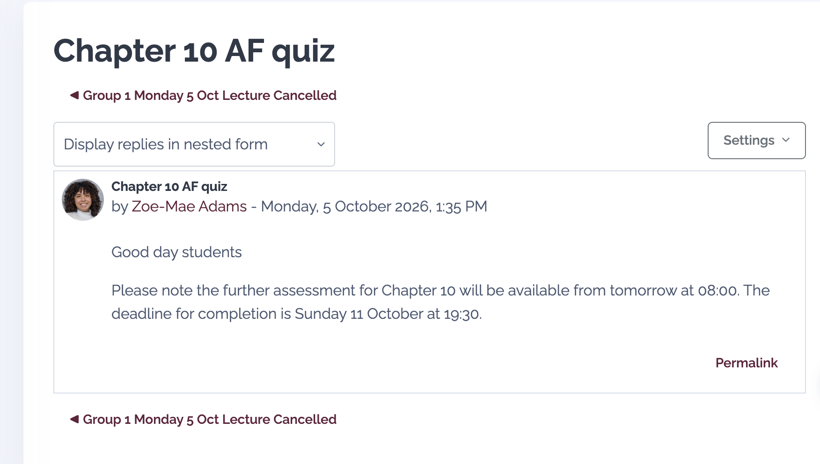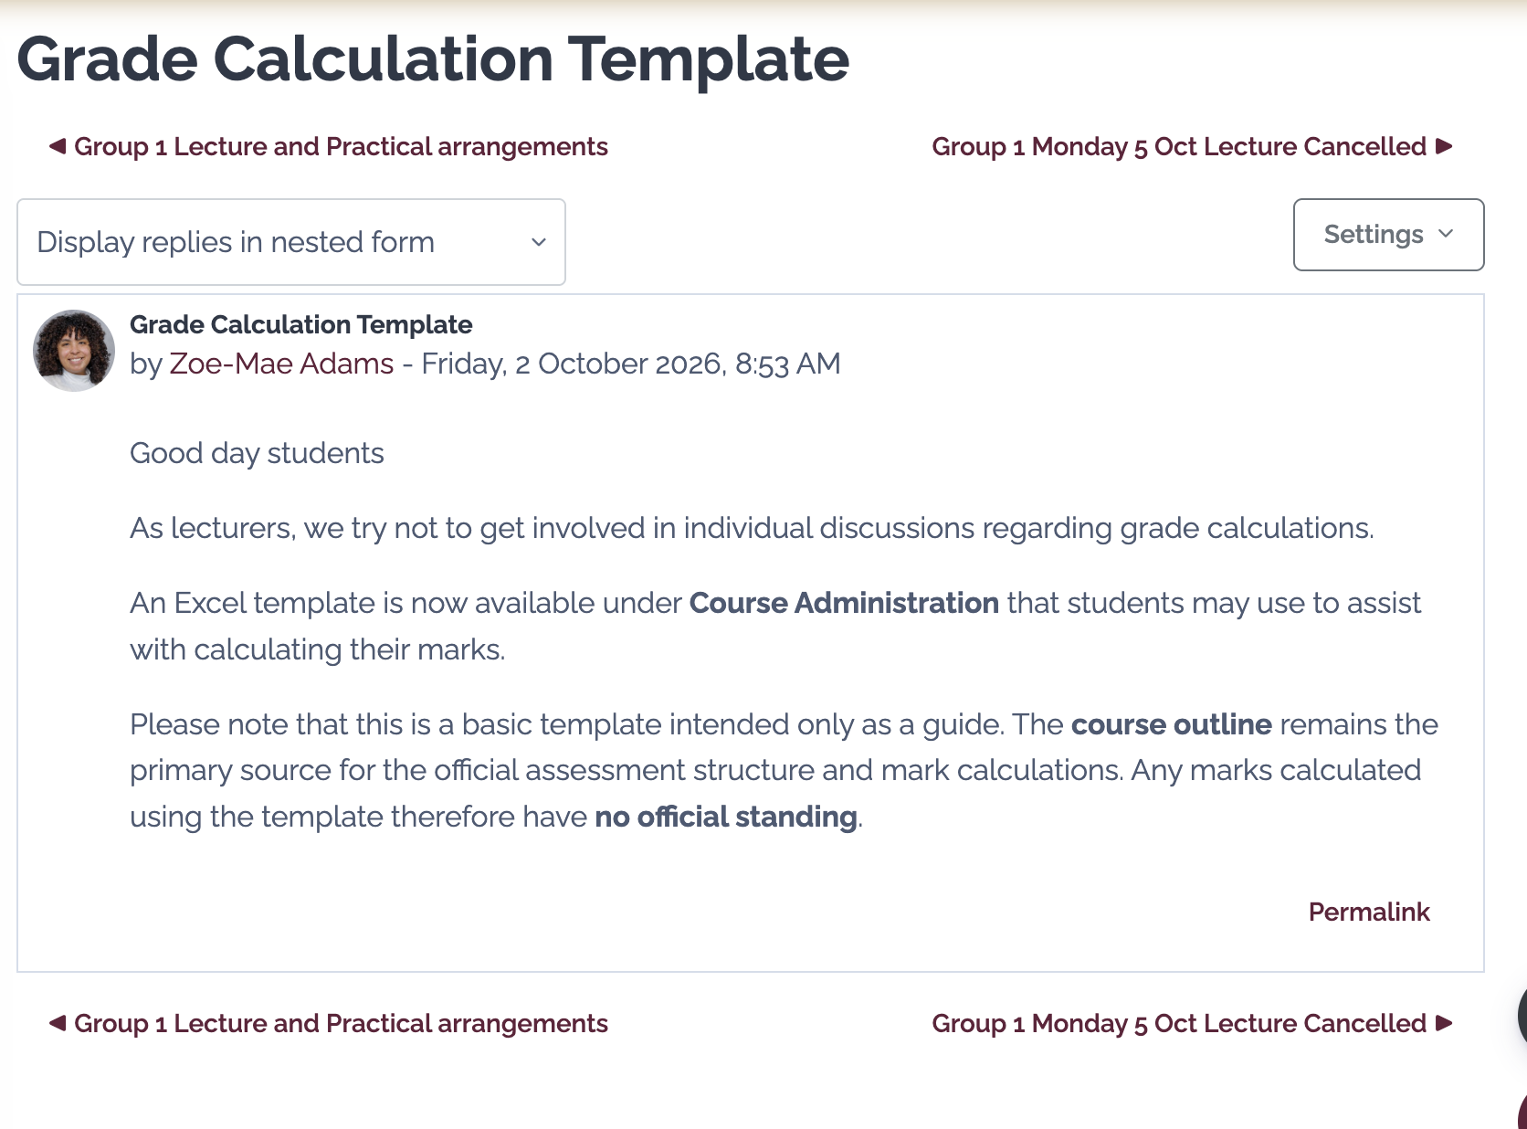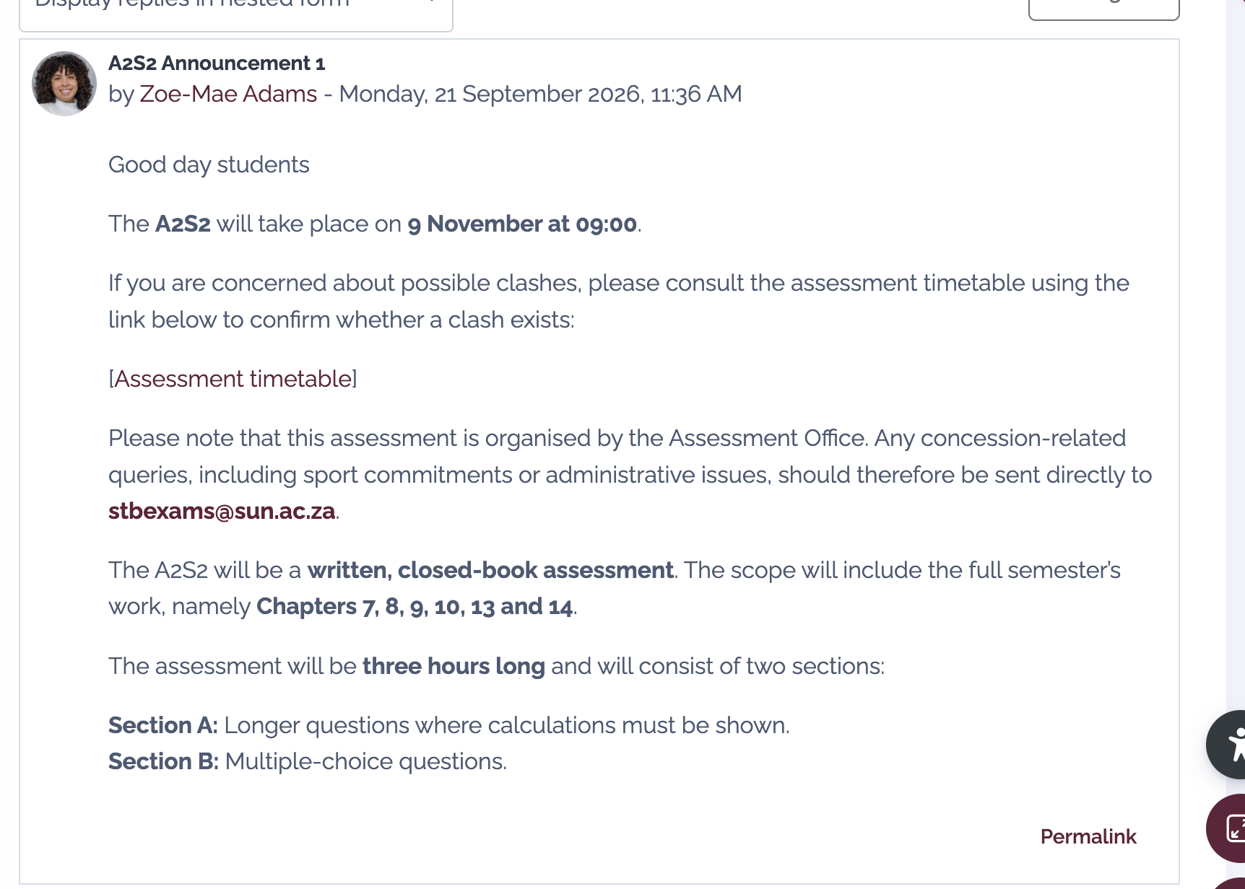

Chapter / Hoofstuk 7
Sampling Distributions / Steekproefverdelings
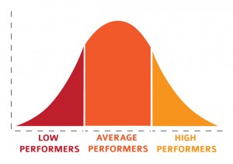
- Chapter 7 Slides
- File
- Hoofstuk 7 Skyfies
- File
- Tutorial 7 / Tutoriaal 7
- File
- Tutorial 7 Solutions / Tutoriaal 7 Oplossings
- File
- Assessment Further (AF) Chapter 7 / Verdereassessering (VAS) Hoofstuk 7
- Quiz
- Opened: Tuesday, 4 August 2026, 8:00 AM
- Closed: Sunday, 9 August 2026, 10:00 PM
- FAS Chapter 7 (Revision) / VAS Hoofstuk 7 (Hersiening)
- Quiz
- Online Topics for Chapter 7

Chapter / Hoofstuk 8
Confidence Interval Estimation / Vertrouensinterval Beraming
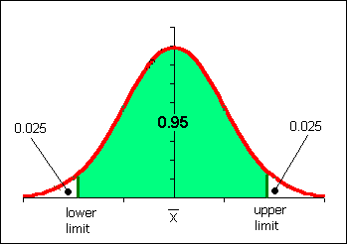
- Chapter 8 Slides
- File
- Hoofstuk 8 Skyfies
- File
- Tutoriaal 8 / Tutorial 8
- File
- Tutorial 8 Solutions / Tutoriaal 8 Oplossings
- File
- T-distribution table / T-verdeling tabel
- File
- Assessment Further (AF) Chapter 8 / Verdereassessering (VAS) Hoofstuk 8
- Quiz
- Opened: Monday, 24 August 2026, 8:00 AM
- Closed: Friday, 28 August 2026, 5:30 PM
- Online Topics for Chapter 8

Chapter 9: Chapter / Hoofstuk 9
Introduction to Hypothesis Testing / Inleiding tot Hipotese Toetsing
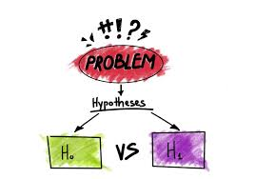
- Chapter 9 slides
- File
- Hoofstuk 9 Skyfies
- File
- Tutoriaal 9 / Tutorial 9

Chapter / Hoofstuk 10
Inference about comparing two populations / Inferensie deur twee populasies te vergelyk
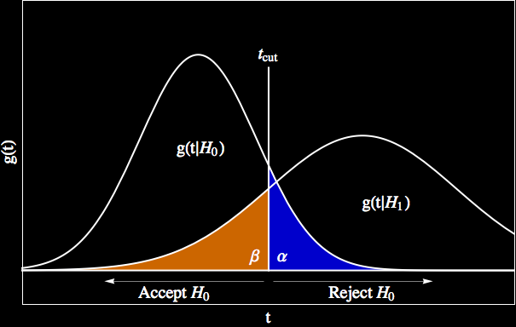
- F Distribution Tables
- File
- Chapter 10 Slides
- File
- Hoofstuk 10 Skyfies
- File
- Tutoriaal 10 / Tutorial 10
- File
- Tutoriaal 10 oplossings / Tutorial 10 solutions
- File
- Assessment Further (AF) Chapter 10 / Verdereassessering (VAS) Hoofstuk 10
- Quiz
- Opened: Tuesday, 6 October 2026, 8:00 AM
- Closes: Sunday, 11 October 2026, 7:30 PM
- Online Topics for Chapter 10
Chapter / Hoofstuk 13
Simple Linear Regression / Eenvoudige Lineêre Regressie
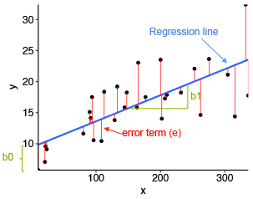
- Chapter 13 Slides
- File
- Hoofstuk 13 Skyfies
- File
- Tutorial 11 / Tutoriaal 11
- File
- This tutorial covers Chapters 13 and 14.
- /
- Hierdie tutoriaal dek Hoofstukke 13 en 14.
- regression_data.xlsx
- Chapter / Hoofstuk 14
- Multiple Linear Regression / Meervoudige Lineêre Regressie
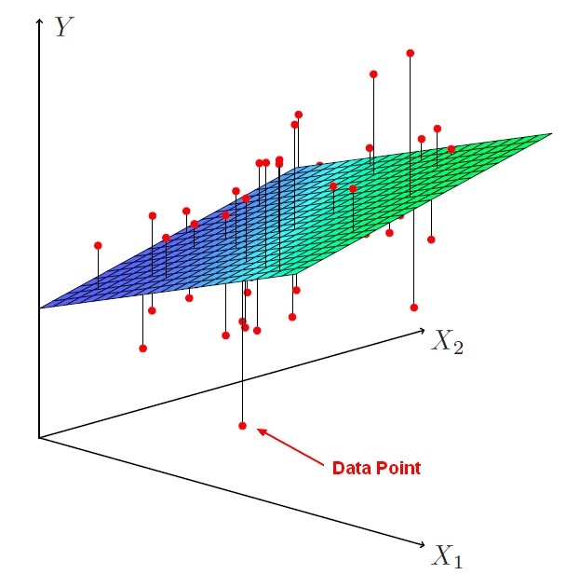
  - Chapter 14 Slides
  - File
  - Hoofstuk 14 Skyfies
  - File
  - THERE IS NO AF FOR CHAPTER 14 / DAAR IS GEEN VA VIR HOOFSTUK 14 NIE

Statistics And Data Science / Statistiek en Datawetenskap - 188
- Course
- Participants
- Grades
- Competencies
Section | Name | Description
Course Administration / Kursusadministrasie | Group 1 - Dr MMC Lamont (Semester 1) | Lecturer:  Dr Morné Lamont (mmcl@sun.ac.za)  Office 2022, Van der Sterr building  Use Entrance 5. At the intercom dial *3246*  Time Venue  Monday 15:10-16:00 3010, Jan Mouton building  Tuesday 09:10-10:00 3010, Jan Mouton building  Thursday 13:10-14:00 FHARGA, Neelsie E01.1 and E01.2  Thursday 14:10-15:00 FHARGA, Neelsie E01.1 and E01.2  Friday 12:10-13:00 3010, Jan Mouton building  Class Rep Group 1 (2026): Grayson Mndeme (28915402@sun.ac.za) WhatsApp Group 1: Link  Click on the links below for additional notes, data and videos.
  Week | Date | Lecture 1 | Lecture 2 | Practical | Lecture 3
  Week | Date | Monday  15:00 | Tuesday  9:00 | Thursday  13:00 | Friday  12:00
  1 | 9-13 Feb | My personal Home Page
  2 | 16-20 Feb |  | Notes: Examples of sampling techniques | Slides: Introduction to Excel  Data Excel: Student data  Student data: Excel solutions  Notes: Tutorial 1 (partial) solutions  YouTube video 2023: Excel intro (1)  YouTube video 2023: Excel intro (2)
  3 | 23-27 Feb | Template: Chapter 2 Excel examples  Excel shortcuts for Chapter 2 | Notes: Chapter 2 | Video 2023: DirtyData Errors  Tutorial 2 Excel template  YouTube video 2023: Tutorial 2 (1)  YouTube video 2023: Tutorial 2 (2) | Solutions: Chapter 2 Excel solutions
  4 | 2-6 Mar |  |  | Tutorial 2 Excel solutions  Notes: Tutorial 2 (Question 8) solution  YouTube video 2023: Tutorial 2 (3) | Notes: Proof of Variance  Notes: Calculator Exercise  YouTube video: Calculator (1) and Calculator (2)
  5 | 9-13 Mar | Exercises: Chapter 3 (Basic Stats)  Solutions: Chapter 3 (Basic Stats) | Exercise: Chapter 3 (five-number summary) | Notes: Tutorial 3 (partial) solutions  YouTube video 2023: Tutorial 3 (1)  YouTube video 2023: Tutorial 3 (2)
  6 | 16-20 Mar | Notes: Proof of covariance  Excel shortcuts for Chapter 3  Excel Chapter 3 Exercise (use Student data) |  | Tutorial 3 Excel template  Tutorial 3 Excel solutions  YouTube video 2023: Tutorial 3 (3)  YouTube video 2023: Tutorial 3 (4)
  7 | 23-27 Mar |  | Notes: Chapter 4 (Rules and tools)  Notes: Table and Venn diagram  Exercise: Chapter 4 (Contingency table) | Notes: Tutorial 4 (partial) solutions  YouTube video 2023: Tutorial 4 (1)  YouTube video 2023: Tutorial 4 (2) | Exercise: Chapter 4 (Bayes rule)  Exercise: Chapter 4 (Venn diagram/Bayes)
  8 | 30 Mar-3 Apr | Recess
  9 | 6-10 Apr |  |  | YouTube video 2023: Tutorial 4 (3) | Exercises: Chapter 5 (Distribution, Expected value, Variance)
  10 | 13-17 Apr | Notes: Calculator exercise  YouTube video: Calculator (3) | Exercises: Chapter 5 (Discrete distributions) | Notes: Tutorial 5 (partial) solutions  YouTube video 2023: Tutorial 5 (1) | Excel shortcuts for Chapter 5  Exercises: Distributions with Excel
  11 | 20-24 Apr |  | Exercise: Chapter 5 (Bivariate distribution) |  | Exercise: Chapter 5 (Sum of X and Y)
  12 | 27 Apr -1 May | Exercise: Chapter 5 (Portfolio)  Formula sheet A2S1 |  | YouTube video 2023: Tutorial 5 (2)  YouTube video 2023: Tutorial 5 (3)
  13 | 4-8 May |  | Exercises: Chapter 6 (Normal probabilities) | Notes: Tutorial 6 (partial) solutions  YouTube video 2023: Tutorial 6 (1)  YouTube video 2023: Tutorial 6 (2)  Percentiles with continuous distributions | Exercise: Chapter 6 (Normal percentiles)  Excel shortcuts for Chapter 6  Template: Chapter 6 Excel examples  Solutions: Chapter 6 Excel examples
  14 | 11-15 May | Exercise: Chapter 6 (Uniform distribution)  Exercise: Chapter 6 (Normal approximation) | Exercise: Chapter 6 (Exponential distribution) | YouTube video 2023: Tutorial 6 (3) | Revision questions  Relationship among distributions
 | Group 1 Semester 2 - Christiaan Hildebrand | Please find pre-recorded videos for lectures here. This is just for the lecture on 28 September and the practical on 1 October 2026.  Chapter 13 Assumptions of the linear model Part 1  Tutorial 11 Part 1  Tutorial 11 Part 2
 | Group 2 - Mr H Sadiq
 | Group 3 - Ms Z Adams | Lecturer:  Ms Z Adams  Office 2003  Van der Sterr building  zadams@sun.ac.za  Link to chat for practical here  Admin:  A recording of the 12 May lecture will be made available. It will discuss the uniform and exponential distribution and a recap of the normal approximation.  You are welcome to arrange a consultation via email. Consultations can take place either in person or via Teams during working hours.  Additional notes:  CHAPTER 1  Chapter 1  Hoofstuk 1  CHAPTER 2  Chapter 2  Hoofstuk 2  Data  CHAPTER 3  Chapter 3  Hoofstuk 3  CHAPTER 4  Chapter 4  Hoofstuk 4  CHAPTER 5  Chapter 5  Hoofstuk 5  AF5 Poisson Bayes  CHAPTER 6  Chapter 6  Hoofstuk 6  12 May Lecture  CHAPTER 7  Chapter 7  Hoofstuk 7  CHAPTER 8  Chapter 8  Hoofstuk 8  CHAPTER 9  Chapter 9  Hoofstuk 9  CHAPTER 10  Chapter 10  Hoofstuk 10
   | Day | Time | Venue
  Lecture | Monday | 10:10-11:00 | Van der Sterr 1011
  Lecture | Tuesday | 08:10-09:00 | Van der Sterr 1011
  Lecture | Friday | 11:10-12:00 | Van der Sterr 1011
  Practical | Wednesday | 15:10-17:00 | Jan Mouton 2017
 | Group 4 & 6 - Ms K Stapelberg | Lecturer:  Ms K Stapelberg  Office 2009  Van der Sterr building  kstapelberg@sun.ac.za  Group 4  Class representative: Angelique Uys (29945984@sun.ac.za)  Group 4 WhatsApp Group  Time Venue  Monday 10:10-11:00 1012, Krotoa building  Tuesday 08:10-09:00 1012, Krotoa building  Thursday 08:10-09:00 Jan Mouton 2017 (Practical)  Thursday 09:00-10:00 Jan Mouton 2017 (Practical)  Friday 11:10-12:00 1012, Krotoa building  Group 6  Class representative: Reuben De Klerk (30924715@sun.ac.za)  Group 6 WhatsApp Group  Time Venue  Monday 11:10-12:00 1015, Chemistry building  Wednesday 10:10-11:00 1015, Chemistry building  Thursday 15:10-16:00 Neelsie FHARGA (Practical)  Thursday 16:10-17:00 Neelsie FHARGA (Practical)  Friday 08:10-09:00 1015, Chemistry building  Additional resources  A1S1  Excel formulas  Chapter 1  Student data and solutions for familiarising yourself with Excel  Chapter 2  Frequency polygon example  Wednesday 25/02 lecture recording (for missed Tuesday class)  Friday 27/02 lecture recording  Tutorial 2 Excel Template  Tutorial 2 Excel Memo  Tutorial 2 Part 1 recording  Tutorial 2 Part 2 recording (plus Q1 of Tutorial 3)  Tutorial 2 Q11 recording  Chapter 3  Monday 02/03 lecture recording  Wednesday 04/03 lecture recording  Friday 06/03 lecture recording  Slide 57 diagram  Monday 09/03 lecture recording  Wednesday 11/03 lecture recording  Friday 13/03 lecture recording  Monday 16/03 lecture recording  Wednesday 18/03 lecture recording  Variance proof  Calculator questions  Chapter 3 revision questions and memo  Tutorial 3 Excel template  Tutorial 3 recording  Chapter 4  Probabilities from a decision tree  Friday 20/03 lecture recording  Monday 23/03 lecture recording  Wednesday 25/03 lecture recording  Friday 27/03 lecture recording  Tutorial 4 part 1 recording  Tutorial 4 part 2 recording  Chapter 5  Wednesday 08/04 lecture recording  Friday 10/04 lecture recording  Monday 13/04 lecture recording  Wednesday 15/04 lecture recording  Friday 17/04 lecture recording  Tutorial 5 part 1 recording  Tutorial 5 Part 2 recording  Tuesday 28/04 lecture recording  Wednesday 29/04 lecture recording  Monday 04/05 lecture recording  Chapter 6  Wednesday 06/05 lecture recording  Tutorial 6 Part 1 recording  Tutorial 6 Part 2 recording  Friday 08/05 lecture recording  Monday 11/05 lecture recording  Wednesday 13/05 lecture recording  Friday 15/05 lecture recording  Chapter 5 and 6 Excel  Chapter 7  Monday 20/07 lecture recording  Wednesday 22/07 lecture recording  Tutorial 5 and 6 Excel and recap recording  Friday 24/07 lecture recording  Monday 27/07 lecture recording  Wednesday 29/07 lecture recording  Tutorial 7 Excel template and memo  Tutorial 7 Part 1 recording  Tutorial 7 Part 2 recording  Chapter 8  Friday 31/07 lecture recording  Monday 03/08 lecture recording  Wednesday 05/08 lecture recording  Friday 07/08 lecture recording  Bootstrap question and data  Wednesday 12/08 lecture recording  Tutorial 8 Part 1 recording  Tutorial 8 Part 2 recording  Tutorial 8 Excel Memo  Chapter 9  Friday 14/08 lecture recording  Monday 17/08 lecture recording  Wednesday 19/08 lecture recording  Friday 21/08 lecture recording  Monday 24/08 lecture recording  Tutorial 9 Excel memo  Wednesday 26/08 lecture recording  Tutorial 9 Part 1 recording  Tutorial 9 Part 2 recording  Friday 28/08 lecture recording  Chapter 10  Monday 31/08 lecture recording  Wednesday 02/09 lecture recording  Tuesday 15/09 lecture recording  Tutorial 10 Part 1 recording  Tutorial 10 Part 2 recording  Friday 18/09 lecture recording  Chapter 13  Monday 21/09 lecture recording  Tuesday 22/09 lecture recording  Monday 28/09 lecture recording  Wednesday 30/09 lecture recording  Friday 02/10 lecture recording  Chapter 14  A1S2 resources  Excel formulas to learn  Formula sheet  CH 9 overview
 | HP10bII+ calculator manual / HP10bII+ sakrekenaar handleiding
 | Template for calculating marks | Please note that this is a crude template to assist you in calculating your marks. The course outline provides the details and should be used as a primary source. The marks obtained in the template therefore have no official standing.
Chapter / Hoofstuk 1 | Chapter 1 Slides
 | Hoofstuk 1 Skyfies
 | Tutorial 1 / Tutoriaal 1
 | Tutorial 1 solutions / Tutoriaal 1 oplossings
 | DirtyData
Chapter / Hoofstuk 2 | Chapter 2 Slides
 | Hoofstuk 2 Skyfies
 | Tutorial 2 / Tutoriaal 2
 | Tutorial 2 Solutions / Tutoriaal 2 Oplossings
Chapter / Hoofstuk 3 | Chapter 3 Slides
 | Hoofstuk 3 Skyfies
 | Tutorial 3 Files / Tutoriaal 3 Lêers
 | Tutorial 3 / Tutoriaal 3
 | Tutorial 3 Solutions / Tutoriaal 3 Oplossings
 | Tutorial 3 Excel Solutions / Tutoriaal 3 Excel Oplossings
Chapter / Hoofstuk 4 | Chapter 4 Slides
 | Hoofstuk 4 Skyfies
 | Tutorial 4 / Tutoriaal 4
 | Tutorial 4 Solutions / Tutoriaal 4 Oplossings
Chapter / Hoofstuk 5 | Chapter 5 Slides
 | Hoofstuk 5 Skyfies
 | Tutorial 5 / Tutoriaal 5
 | Tutorial 5 Solutions / Tutoriaal 5 Oplossings
 | Tutorial 5 Typo Note
Chapter / Hoofstuk 6 | Chapter 6 Slides
 | Hoofstuk 6 Skyfies
 | Tutoriaal 6 / Tutorial 6
 | Tutoriaal 6 data / Tutorial 6 data
 | Tutorial 6 Solutions / Tutoriaal 6 Oplossings
Chapter / Hoofstuk 7 | Chapter 7 Slides
 | Hoofstuk 7 Skyfies
 | Tutorial 7 / Tutoriaal 7
 | Tutorial 7 Solutions / Tutoriaal 7 Oplossings
 | Online Topics for Chapter 7
Chapter / Hoofstuk 8 | Chapter 8 Slides
 | Hoofstuk 8 Skyfies
 | Tutoriaal 8 / Tutorial 8
 | Tutorial 8 Solutions / Tutoriaal 8 Oplossings
 | T-distribution table / T-verdeling tabel
 | Online Topics for Chapter 8
Chapter / Hoofstuk 9 | Chapter 9 slides
 | Hoofstuk 9 Skyfies
 | Tutoriaal 9 / Tutorial 9
 | Tutoriaal 9 oplossings / Tutorial 9 solutions
Chapter / Hoofstuk 10 | F Distribution Tables
 | Chapter 10 Slides
 | Hoofstuk 10 Skyfies
 | Tutoriaal 10 / Tutorial 10
 | Tutoriaal 10 oplossings / Tutorial 10 solutions
 | Online Topics for Chapter 10
Chapter / Hoofstuk 13 | Chapter 13 Slides
 | Hoofstuk 13 Skyfies
 | Tutorial 11 / Tutoriaal 11 | This tutorial covers Chapters 13 and 14.  /  Hierdie tutoriaal dek Hoofstukke 13 en 14.
 | regression_data.xlsx
Chapter / Hoofstuk 14 | Chapter 14 Slides
 | Hoofstuk 14 Skyfies
A2S2 Assessment / Assessering 2026 | A2S2 Formula sheet / Formuleblad
Module Framework / Moduleraamwerk | Module Framework 2026
 | Moduleraamwerk 2026
Additional Resources / Addisionele Bronne | Seeing Theory: A visual introduction to probability and statistics | An interactive textbook for introductory statistics classes in high school and college.
 | SUNLearn/ IT help | For SUNLearn support  1. Log a request online: https://learnhelp.sun.ac.za/  2. For every urgent queries call: 021 808 2222  For IT support  1. Log a request online: https://servicedesk.sun.ac.za/  2. Or e-mail: help@sun.ac.za  3. For every urgent queries call: 021 808 4367  Register your device and connect to SU Wifi: http://ebwrga.sun.ac.za/faq/  For first time users (who have not yet used MS Teams or logged in at Office 365):  1. Go to https://www.office.com  2. Click on Sign in at the top right  3. Log in with your [student number]@sun.ac.za email address and network password  4. Your profile is now created on Office 365.
 | Named ranges in Excel / Benoemde reekse in Excel

